1. 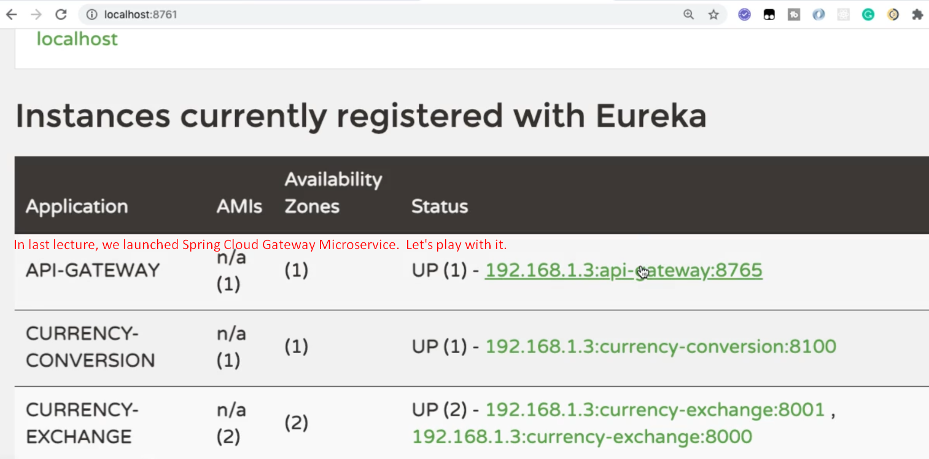
2. 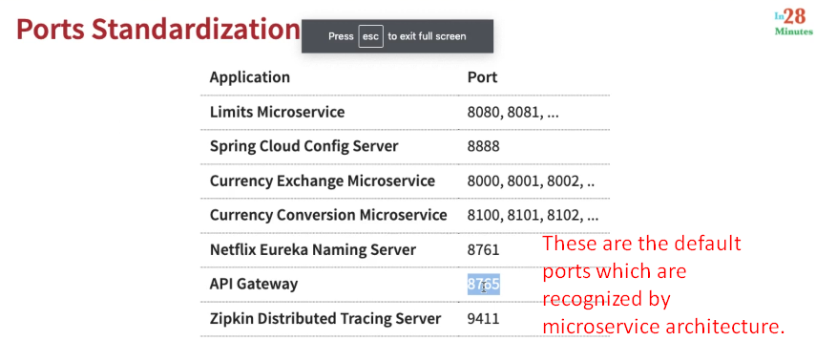
3. 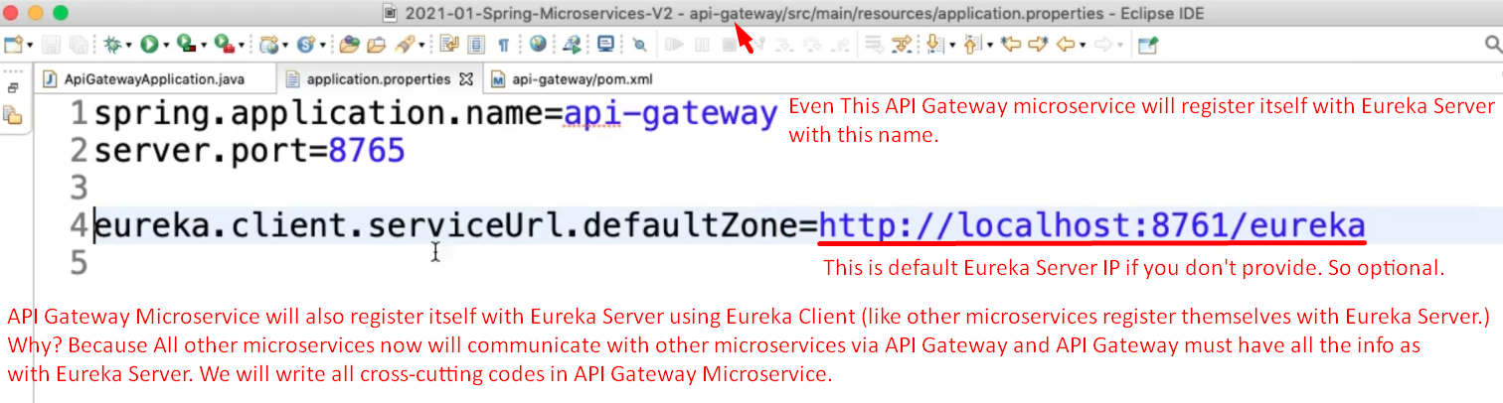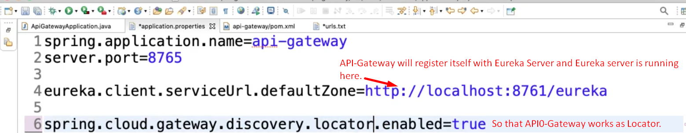
4. Let’s make API-Gateway URLS which are correspondence to actual end-points exposed by each microservice.
5. 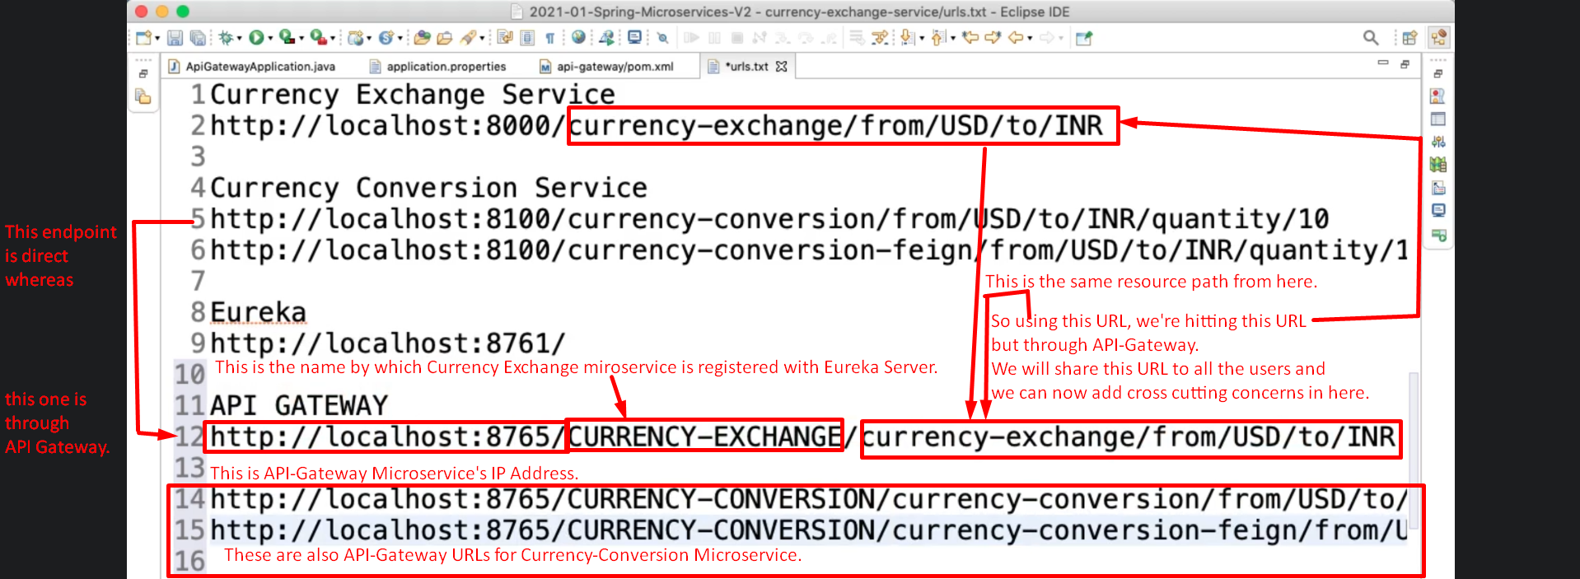
6. 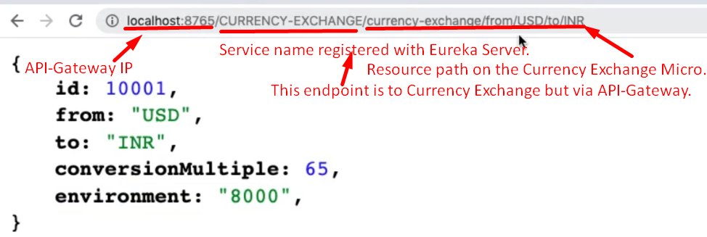
7. NOTE: Actually this is the URL for Currency-Exchange that we share with others using it actually this URL is via API Gateway.